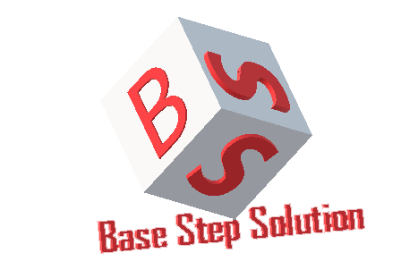

Configuration Managemet Plan

Văn Lang Admissions

# Revision Table

|  |  |  |  |
| --- | --- | --- | --- |
| Author | Date | Reason for changes | Version |
|  |  |  |  |
|  |  |  |  |
|  |  |  |  |
|  |  |  |  |
|  |  |  |  |
|  |  |  |  |
|  |  |  |  |

Table of Contents

Revision Table 1

1. INTRODUCTION 3

1.1. Purpose 3

1.2. Definitions, acronyms and abbreviations 3

1.3. Audience 4

2. CONFIGURATION MANAGEMENT 4

2.1. Organization 4

2.2. Policies 6

2.3. Training 6

3. CONFIGURATION MANAGEMENT ACTIVITIES 7

3.1. Configuration Items 7

3.2. Configuration Identification 7

3.2.1. Document name 7

3.2.2. Document content 9

3.2.3. Tool for store and access to the repository 12

3.2.4. Tool for testing 13

3.2.6. Tools for product development 13

3.2.7. Organize folders to store document 13

3.2.8. Process to add or modify Capstone Project’s documents on Google Drive 16

3.3. Artifact Life Cycle 17

3.4. Manage version 18

3.4.1. Update Status Change of the Document (Revision Table) 18

3.4.2. Set Version for Document 18

APPENDIX A: REFERENCES 18

# INTRODUCTION

## Purpose

## Definitions, acronyms and abbreviations

This following table describes key terms and important acronyms in this project:

|  |  |  |
| --- | --- | --- |
| No. | Term | Definition |
|  |  |  |
|  |  |  |
|  |  |  |
|  |  |  |

## Audience

|  |  |
| --- | --- |
| Intended Audience | Description |
|  |  |
|  |  |
|  |  |
|  |  |

# CONFIGURATION MANAGEMENT

## Organization

## Policies

## Training

# CONFIGURATION MANAGEMENT ACTIVITIES

## Configuration Items

|  |  |  |
| --- | --- | --- |
| No. | Category | Item List |
|  |  |  |
|  |
|  |  |  |
|  |
|  |  |  |
|  |
|  |
|  |
|  |  |  |

## Configuration Identification

### Document name

### Document content

#### Word Document

|  |  |  |
| --- | --- | --- |
| No. | Item | Convention |
|  |  |  |
|  |  |  |
|  |  |  |
|  |  |  |
|  |  |  |
|  |  |  |
|  |  |  |

Table 1: Word Document Convention

#### Excel Document

|  |  |  |
| --- | --- | --- |
| No. | Item | Convention |
|  |  |  |
|  |  |  |
|  |  |  |

Table 2: Excel Document Convention

### Tool for store and access to the repository

|  |  |
| --- | --- |
| Item | Description |
|  |  |
|  |  |
|  |  |
|  |  |

|  |  |
| --- | --- |
| Item | Description |
|  |  |
|  |  |
|  |  |
|  |  |

|  |  |
| --- | --- |
|  |  |

1. Tools for editing documents

|  |  |
| --- | --- |
| Name | Description |
|  |  |

Table 3: Tools for editing document

### Tools for product development

|  |  |
| --- | --- |
| Name | Description |
|  |  |
|  |  |

Table 4: Tools for product development

### Organize folders to store document

|  |  |  |
| --- | --- | --- |
| **Root Folder** | **Sub Folder** | **Description** |
|  |  |  |
|  |  |  |
|  |  |  |
|  |  |  |
|  |  |  |
|  |  |  |
|  |  |  |
|  |  |  |
|  |  |  |
|  |  |  |
|  |  |  |
|  |  |  |
|  |  |  |

Table 6:Final Folder Structure in Github

### 3.2.8. Process to add or modify Capstone Project’s documents on Github

## Artifact Life Cycle

|  |  |  |  |
| --- | --- | --- | --- |
| No. | Configuration Item | Start | End |
|  |  |  | |
|  |  |  | |
|  |  |  | |
|  |  |  | |
|  |  |  | |
|  |  |  |  |
|  |  |  | |

Table 7: Artifact Life Cycle

## Manage version

### Update Status Change of the Document (Revision Table)

|  |  |  |  |
| --- | --- | --- | --- |
| Author | Date | Describe about changes | Version |
|  |  |  |  |

Table 8: Update version to revision table

### Set Version for Document

# APPENDIX A: REFERENCES